ECE215 - Monsoon 2025: Project

Problem statement:
Consider the circuit given in Fig. 1, this is a third order active LPF. Using this circuit design a 3rd-order low-pass filter having a cut-off frequency of 1KHz with and a flat band gain of 12dB. The filter must be designed from the set of available components provided in the lab. The list of available hardware can be found at this link (Click Here).

Specifications:
The LPF filter should meet the following specifications.
- The slope after the pass band that needs to be obtained is 60 dB/decade.
- There must be one variable resistor that needs to be part of the filter circuit, and it can be used to adjust the gain, given that the gain, as mentioned in the problem statement (12dB), should be achievable.
- The gain achieved up to 3.5dB will also be considered acceptable. A 10% deviation is allowed in the cutoff frequency. The deviation allowed in the slope obtained in the stop band is 30%.

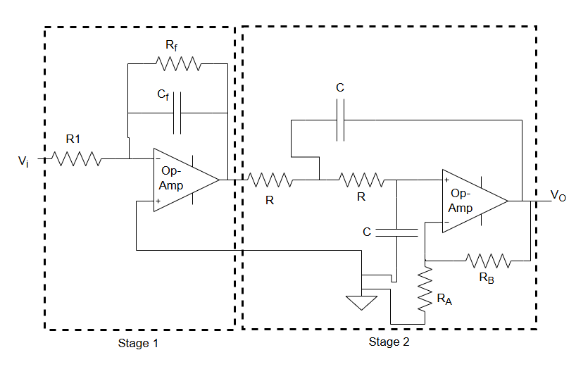
Fig. 1

Here, Stage 2 is a Sallen-Key prototype (for ref reading, read the Advance Filter Design section of Engineering Circuit Analysis, 9th Edition: William H. Hayt, page no. 671).

The transfer function of stage 2 will be,

$\frac{\frac{G}{R^{2}C^{2}}}{S^{2}+ \frac{1}{RC}{(3-G)S}^{}+\frac{1}{R^{2}C^{2}}}$
The transfer function of stage 1 will be,
- $\frac{\frac{1}{R_{1}C_{f}}}{S^{}+ \frac{1}{R_{1}C_{f}}}$
Hence, the overall magnitude of the transfer function would be,
($\frac{\frac{1}{R_{1}C_{f}}}{S^{}+ \frac{1}{R_{1}C_{f}}}$) ($\frac{\frac{G}{R^{2}C^{2}}}{S^{2}+ \frac{1}{RC}{(3-G)S}^{}+\frac{1}{R^{2}C^{2}}}$) (1)

Hints for filter design techniques:

There are various methods to design advanced filters. One of the popular filters that exists is a Butterworth filter. The general form of the transfer function of the n^{th} order Butterworth filter is given below (magnitude response):

|$H(jω)|$ = $\frac{K}{\sqrt{1+{(\frac{ω}{ω_{C}})}^{2n}}}$ (2)
Here, we see that if n tends to infinity, then the passband gain ($\frac{ω}{ω_{C}}$ < 1) will be K, and the stopband gain ($\frac{ω}{ω_{C}}$ >1) will be zero. This makes it clear that, as we increase the order of the filter, n will increase and hence the response of the filter will become more and closer to the ideal response.

The above transfer function(2), of the n^{th} order Butterworth filter, can also be expressed in the form of a generalized polynomial in normalized form as:

H(S) = $\frac{1}{S^{n}+ a_{n-1}S^{n-1}+a_{n-2}S^{n-2}+.........................{+a}_{1}S^{}+a_{0}}$
Where the normalized coefficients are given as,
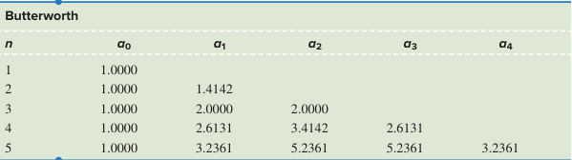
(Ref: Engineering Circuit Analysis, 9th Edition: William H. Hayt)

Now, in order to have a third order Butterworth filter (n = 3). We have a₀ = 1, a₁ = 2, and a₃ = 2.
Hence, the denominator polynomial would become,

$S^{3}+ 2S^{2}+2S^{}+1 = 0$ (3)

and hence the normalized transfer function for the 3rd order Butterworth filter would be
$\frac{1}{(S+1)(S^{2}+S^{}+1)}$ (4)

Now for a cut-off frequency of 1KHz, and a gain of 12dB the denormalized TF obtained from (4) will be approximately given as (for ref reading read the Advance Filter Design section of Engineering Circuit Analysis, 9th Edition: William H. Hayt, page no. 657),

$\frac{Kω_{C}^{3}}{S^{3}+ 2{ω_{C}S^{2}}^{}+ {2ω}_{C}^{2}S +{ ω}_{C}^{3}}$ (5)
By putting the values of the cut-off frequency, the condition of 12dB gain at DC, and by comparing the (1) with (5) the values of the components can be estimated.

Note for students:
The hint provided in the above section is for the reference purposes only, and it does not claim the exact solution to the problem statement of the project. The student can refer to the resources from the lecture material/reference books, for the purpose of analysing their design.

